**Laboratory Report Cover Sheet**

|  |
| --- |
| SRM Institute of Science and Technology  College of Engineering and Technology  Department of Electronics and Communication Engineering |
| **18ECC204J DIGITAL SIGNAL PROCESSING**  **Fifth Semester, 2022-23 (Odd semester)** |

**Name :**

**Register No. :**

**Day / Session :**

**Venue :**

**Title of Experiment :**

**Date of Conduction :**

**Date of Submission :**

|  |  |  |
| --- | --- | --- |
| **Particulars** | **Max. Marks** | **Marks Obtained** |
| Prelab and Post lab | 10 |  |
| Lab Performance | 10 |  |
| Simulation and results | 10 |  |
| Total | 30 |  |

**REPORT VERIFICATION**

**Staff Name :**

**Signature :**

Lab 15a: Design of anti-aliasing filter

Aim: To study the characteristics of anti-aliasing filter

Software Requirement: SCI Lab

Theory: An **anti-aliasing filter** (**AAF**) is a filter used before a signal sampler to restrict the bandwidth of a signal to satisfy the Nyquist–Shannon sampling theorem over the band of interest. Since the theorem states that unambiguous reconstruction of the signal from its samples is possible when the power of frequencies above the Nyquist frequency is zero, a brick wall filter is an idealized but impractical AAF. A practical AAF trades off between bandwidth and aliasing. A practical anti-aliasing filter will typically permit some aliasing to occur or attenuate or otherwise distort some in-band frequencies close to the Nyquist limit. For this reason, many practical systems sample higher than would be theoretically required by a perfect AAF in order to ensure that all frequencies of interest can be reconstructed, a practice called oversampling.

As we have seen, when sampling a signal that contains frequencies that are above half of the sampling frequency, the sampling maps these to some other frequencies within the Nyquist frequency. These so-called image frequencies or alias frequencies are often unwanted, since they do not represent the original signal. Instead, one uses an anti-aliasing filter (AAF) to filter the input signal before sampling.

The anti-aliasing filter is basically a low-pass filter with (ideal) cutoff frequency of Fs/2. Hence, it blocks all frequencies that would create images in the sampled signal, before sampling the signal. Accordingly, there is a loss in the information about high frequencies when applying the anti-aliasing filter. However, the same loss would again be incurred when sampling the signal with frequency Fs/2, since the output frequencies cannot be unambiguously mapped to the input frequencies due to the aliasing effect.

In practice, the analog signal to be digitized may contain other frequency components in addition to the folding frequency, such as high-frequency noise. To satisfy the sampling theorem condition, we apply an anti-aliasing filter to limit the input analog signal, so that all the frequency components are less than the folding frequency (half of the sampling rate). Considering the worst case, where the analog signal to be sampled has a flat frequency spectrum, the band-limited spectrum X( f ) and sampled spectrum Xs( f ) are depicted in Figure given below, where the shape of each replica in the sampled signal spectrum is the same as that of the anti-aliasing filter magnitude frequency response.

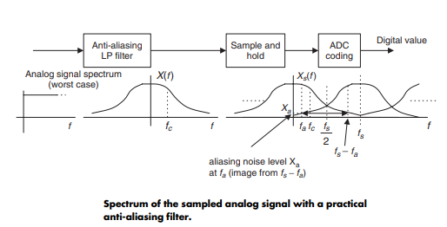

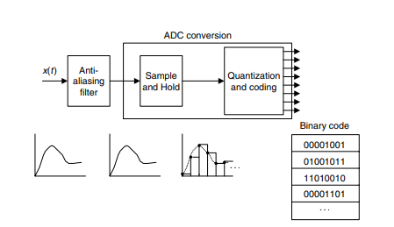

15a) Design of anti-aliasing filter

**Scilab code: Anti-Aliasing Filter**

clc ;

clf ;

clear all;

b=input('enter no of bits');

n=input('enter band width in KHZ');

As=20*log10(2^b*sqrt(6));

Vs=(10^(0.1*As)-1)^(1/(2*n));

fp=4;

fs=Vs*fp;

S=2*fs;

fa=S-fp;

Va=fa/fp;

Aa =10* log10 (1+ Va ^(2* n ) )

Simulation Output:

|  |  |  |
| --- | --- | --- |
| No of bits | Frequency in (KHz) | OUTPUT |
| 4 | 50 |  |
| 8 | 100 |  |
| 12 | 150 |  |

Simulation Output:

* Output for b = 4 & n = 50 Hz

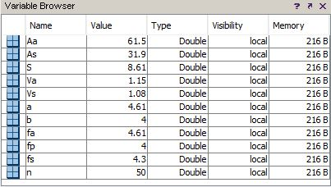

* Output for b = 8 & n = 100 Hz

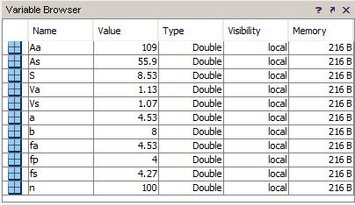

* Output for b = 12 & n = 150 Hz

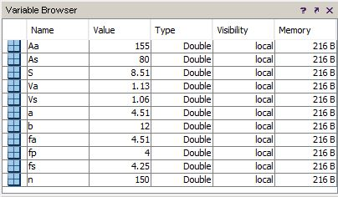

**Laboratory Report Cover Sheet**

|  |
| --- |
| SRM Institute of Science and Technology  Faculty of Engineering and Technology  Department of Electronics and Communication Engineering |
| **18ECC204J DIGITAL SIGNAL PROCESSING**  **Fifth Semester, 2020-21 (Odd semester)** |

**Name :**

**Register No. :**

**Day / Session :**

**Venue :**

**Title of Experiment :**

**Date of Conduction :**

**Date of Submission :**

|  |  |  |
| --- | --- | --- |
| **Particulars** | **Max. Marks** | **Marks Obtained** |
| Pre lab and Post lab | 10 |  |
| Lab Performance | 10 |  |
| Simulation and results | 10 |  |
| Total | 30 |  |

**REPORT VERIFICATION**

**Staff Name :**

**Signature :**

15b) Design of anti-imaging filter

Theory : In a mixed-signal system (analog and digital), a **reconstruction filter**, sometimes called an **anti-imaging filter**, is used to construct a smooth analog signal from a digital input, as in the case of a digital to analog converter (DAC) or other sampled data output device.

While in theory a DAC outputs a series of discrete Dirac impulses, in practice, a real DAC outputs pulses with finite bandwidth and width. Both idealized Dirac pulses, zero-order held steps and other output pulses, if unfiltered, would contain spurious high-frequency replicas, "*or images*" of the original bandlimited signal. Thus, the reconstruction filter smooths the waveform to remove image frequencies (copies) above the Nyquist limit. In doing so, it reconstructs the continuous time signal (whether originally sampled, or modelled by digital logic) corresponding to the digital time sequence.

Practical filters have non-flat frequency or phase response in the pass band and incomplete suppression of the signal elsewhere. The ideal [sinc](https://en.wikipedia.org/wiki/Sinc_function) waveform has an infinite response to a signal, in both the positive and negative time directions, which is impossible to perform in real time – as it would require infinite delay. Consequently, real reconstruction filters typically either allow some energy above the Nyquist rate, attenuate some in-band frequencies, or both. For this reason, oversampling may be used to ensure that frequencies of interest are accurately reproduced without excess energy being emitted out of band.

In systems that have both, the anti-aliasing filter and a reconstruction filter may be of identical design. For example, both the input and the output for audio equipment may be sampled at 44.1 kHz. In this case, both audio filters block as much as possible above 22 kHz and pass as much as possible below 20 kHz.

Alternatively, a system may have no reconstruction filter and simply tolerate some energy being wasted reproducing higher frequency images of the primary signal spectrum.

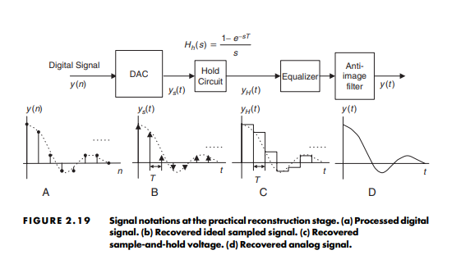

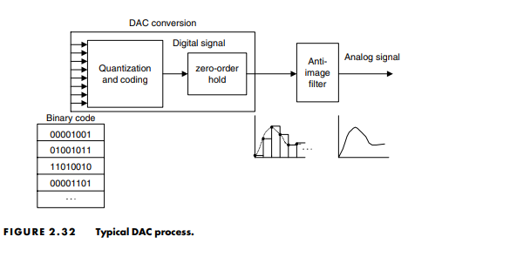

**Scilab code: anti-imaging filter**

Program:

clc ;

clf ;

clear all;

// Anti Imaging Filter considerations

Ap =0.5; // pass band attenuation

fp =20; // pass band edge frequency

As =60; // stop band attenuation

S =42.1;

fs =S - fp ; // stop band edge frequency

e = sqrt (10^(0.1* Ap ) -1) ;

e1 = sqrt (10^(0.1* As ) -1) ;

n =( log10 ( e1 / e ) ) /( log10 ( fs / fp ) ) ;

n = ceil ( n ) // design of nth order but worth filter

// ( b ) Assuming Zero−order hold sampling

S1 =176.4;

fs1 = S1 - fp;

Ap =0.316;

e2 = sqrt (10^(0.1* Ap ) -1);

n1 =( log10 ( e1 / e2 ) ) /( log ( fs1 / fp ) ) ; //new o r d e r of but worth filter

n1 = ceil ( n1 )

f =0:100;

x = abs( sinc ( f * %pi / S ) ) ;

f1 =0:500;

x1 =abs( sinc ( f1 * %pi / S1 ) ) ;

a = gca () ;

subplot (211) ;

plot2d (f , x ) ;

xtitle (” spectra under normal sampling condition ” ,” f (kHZ ) ” ,” s i n c ( f / s1 ) ”) ;

subplot (212);

plot2d ( f1,x1 );

xtitle (” spectra under over sampling condition ” ,” f (kHZ ) ” ,” s i n c ( f / s1 ) ”);

**Simulation Output:**

**Anti Imaging Filter Consideration**

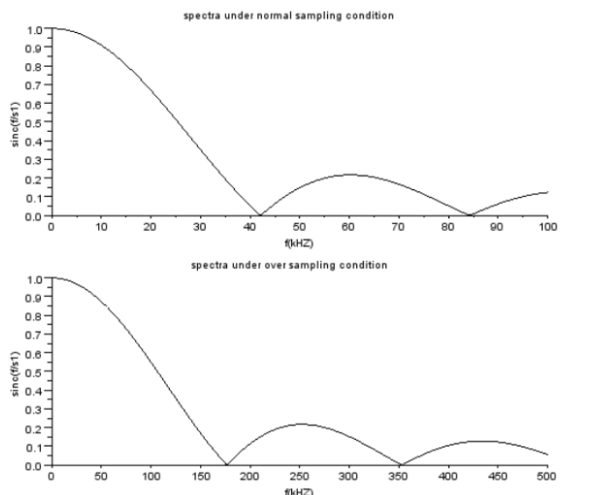

Pre-lab questions:

1. What is meant by anti-aliasing filter l?
2. What is the filter used for anti-aliasing?
3. Mention the advantages of anti-aliasing filter.

Post-Lab questions:

1. What is meant by anti-Imaging filter?
2. Mention the difference between anti-aliasing and anti-imaging filter.
3. Mention the advantages of the anti-imaging filter.

Result: